**CS 157A Project Data Model & DB Design Document**

**Three-Tier Web Application**

**SJSU Bookie**



Cole McKinnon, Jonathan Van, Yu Xiu

Team 4

Advisor: Dr. Mike Wu

Oct. 08, 2019

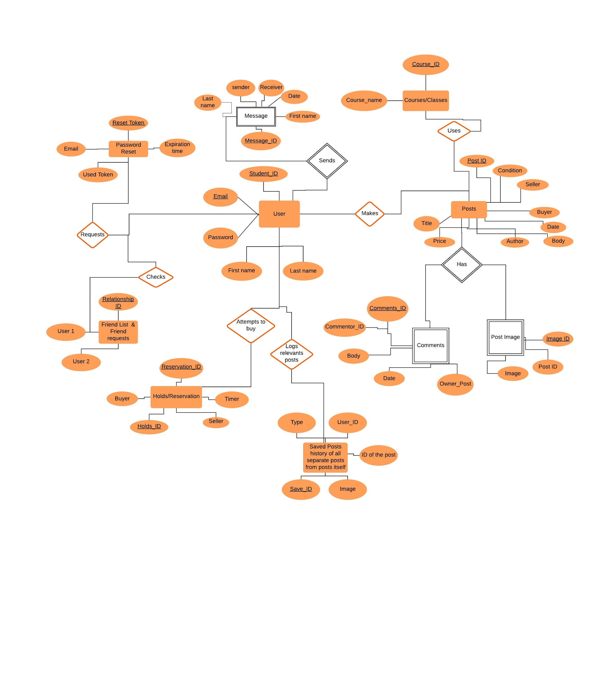

Figure 1: SJSUBookie E/R Diagram

**Explanations for E/R Diagram:**

* **Tables**
  + User
    - The users who are using our SJSU Bookie. The Unique keys are the user’s email and student ID.
  + Password Reset
    - Unique key is the reset token where this allows the user to be able to reset their password in case they forgot it. Token is used as validation and identification.
  + Post
    - Posted by a user, this entity has details of the book they are trying to sell. Another user can put a hold, view or comment on it, but only the original poster can edit/delete the posting. These are recognized by the post id.
  + Saved Posts
    - This is a log/list of posts that is relevant to a user. These posts can include posts that you’ve made, posts that you’ve commented on, or posts that you favorited. These are identified by the post_id and saved_id
  + Messages
    - Users can send messages to other users, but the constraint is the person must be a user, then he or she can send messages to other users. The message ID number is the unique key.
  + FriendList/Friend Friend Requests
    - A user is able to add another user as their friend on SJSUBookie in order to maintain communication or be able to communicate with one another. A friend request is considered accepted when both users recognize that the other is the friend on the database. These are uniquely identified by the relationship ID.
  + Holds/Reservations
    - A hold is basically a contract stating that one user is interested in another user’s post. This is temporary let other users know that the book might be bought. Identified by Hold/Reservation_ID.
  + Comments
    - Users can leave comments under a post. The unique key of comments is comment ID, which we use to identify the comments.
  + Post Image
    - It will be a table of images the user uploaded. The users would upload images when they are creating a selling post. The unique key is the image ID.
  + Course/Classes
    - Course is to help posts identify which class/course the book belongs to. Identified by the course_ID like (CS157A, CMPE165… etc)